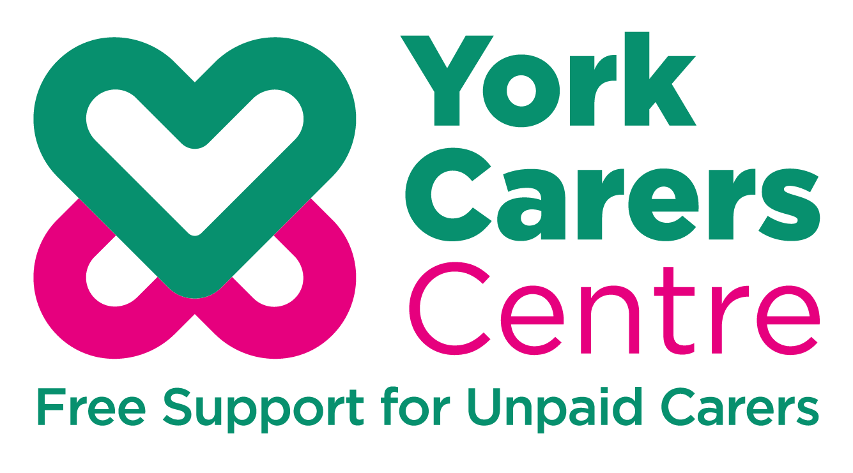

Application Pack

York Carers Centre

Carer Support Worker

Welcome from the CEO

I am delighted that you are interested in the role of Carer Support Worker at York Carers Centre.
Are you someone who has experience of providing unpaid care or experience of working with carers or people with mental ill health? Do you feel in a position to use your experience to support others?

As an independent charity supporting unpaid carers in York, we are looking for a highly motivated and organised individual to join our friendly dedicated team, helping unpaid carers to maintain their health and wellbeing through the provision of information, advice and support.

As a Carer Support Worker, you will organise and facilitate regular focus and peer support groups specifically for carers of people with mental ill health, alongside supporting casual staff to deliver hospital drop-ins for carers.

This is an exciting opportunity for people who have a genuine interest in using their previous experience to support others, who are able to work within the boundaries of confidentiality and can work effectively with a wide range of clients, to provide group work and one to one emotional support.
If you are able to advocate on behalf of vulnerable individuals and have knowledge of the voluntary and statutory services then you may be the person we are looking for.
Successful applicants will have the confidence to develop effective partnerships, brokering services for unpaid carers and promoting unpaid carers needs to public, private and voluntary agencies. An understanding of the needs and rights of unpaid carers will be needed.
The role will involve flexible working, including evening work, travelling to and working from a range of outreach venues.
We offer a supportive working environment with learning and development opportunities, 29 days holiday per year plus public holidays, reduced pro rata, and a contributory pension scheme.
We are committed to equal opportunities for all and especially welcome applications from BAME backgrounds.

If you are passionate about providing support to carers and their families and you thrive on your work making a direct difference then I really look forward to hearing from you.

Best wishes

Carole Zagrovic
Chief Executive
About York Carers Centre

York Carers Centre is an independent charity and a network member of the national Carers Trust. We work in partnership with carers, statutory and voluntary organisations to ensure unpaid carers throughout York have access to confidential information, advice and support. We work with carers to influence positive change in service delivery with local government, employers, schools and health providers.
York Carers Centre supports carers of all ages:
- Adults
- Young adults (18 to 25)
- Young carers (5 to 18)
Our funding comes from a variety of sources and our principal funders are the City of York Council and the Vale of York Clinical Commissioning Group.
We rely on grants from charitable trusts and on donations and fundraising to enable us to deliver specific projects.

Our vision
Our vision is that unpaid carers, of all ages, in York are valued, recognised and supported to have a good quality of life.

Our mission
Our mission is to challenge the inequalities unpaid carers face, and ensure carers have access to support and services that reflect their needs and interests.

Job Description

Job Title: Carer Support Worker

Salary: £22,627 per annum pro rata

Hours: 15 hours per week (excluding lunch breaks) to be worked flexibly to include evening work

Contract: One year fixed term contract with the possibility of an extension depending on funding.

Location: York Carers Centre, 17 Priory Street, York YO1 6ET

Reporting to: Lead Officer for Adult Carers

Main Purpose of Job:
To support carers of people with mental ill health to access a range of information, advice and one-to-one support alongside facilitating regular peer support groups, focus groups and training sessions to help carers maintain their health and wellbeing and give them a better understanding of specific mental health conditions.
To ensure carers are aware of services to support them in their caring roles and of their rights including a Carers Assessment of Need.
The role will include working alongside Foss Park hospital staff and other professionals, to ensure carers are identified and supported specifically when the person they care for is in or being discharged from hospital.
To oversee the provision of Peer Carer Supporters who will provide regular drop in sessions at the hospital.
Key Responsibilities:
1. Organise and facilitate regular focus groups and peer support groups for carers of those recently discharged from hospital to help them to access relevant information and support.
2. Provide one-to-one support to ensure carers have appropriate discharge plans and access to services.
3. Deliver training sessions to assist carers to better understand mental health conditions, navigate systems and access support available from voluntary and community sector services.
4. Support sessional staff to deliver regular hospital drop-ins for carers.
5. Help carers respond to their caring issues, where appropriate with health and social carer providers.
6. Identify the most vulnerable carers through partnership working, referrals etc and ensure they have the support they need.
7. Attend meetings as required with partner organisations.
8. Take an active role in the development of specialist group work.
9. Provide written reports to Managers as required.
10. Maintain casework and client records on York Carers Centre database system (eg Charity Log) observing client confidentiality and Data Protection Policy.
General requirements: The postholder will be expected to:
· Possess the essential skills detailed in the person specification
· Be able to work alongside a range of professionals from statutory and voluntary sectors on a new project
· Actively identify own training needs and personal development, including staying abreast of safeguarding, diversity, confidentiality and health and safety issues.
· Participate in team meetings and individual supervision and appraisal according to York Carers Centre policies/procedures
· To be flexible with your availability as the role will include evening working
· Maintain communication systems within York Carers Centre to enable joint working and managerial oversight
· Adhere to and uphold York Carers Centre values, strategic aims, policies and quality standards
· To be responsible for the application of York Carers Centre Health and Safety Policy and procedures, including carrying out risk assessments for activities and ensuring necessary actions are taken to maintain or improve safety and mitigate risks
· Act with integrity and maintain the highest professional standards at all times
· Maintain a confidential, sensitive and discrete approach to personal, sensitive and organisational information
· Contribute to a culture of equality and demonstrate a commitment to removing all forms of discrimination as a colleague and as a provider of services to carers
An enhanced DBS check will be required for this post.
This job description is not necessarily an exhaustive list of duties but is intended to reflect a range of duties the post-holder will perform. The post-holder may be required to undertake other duties from time to time commensurate with the post.
Person Specification: Carer Support Worker
 | Essential | Desirable | How assessed*
Values and Personal Attributes
1.1 Ability to work under pressure to meet strict deadlines in an organized, efficient and methodical manner. |  |  | AF/INT/R
1.2 Self-motivated and energetic. Able to work independently and as part of a team. |  |  | AF/INT/R
1.3 Possess sensitivity, empathy and understanding and able to apply this when dealing with carers |  |  | AF/INT/R
1.4 A positive attitude |  |  | AF/INT/R
1.5 Possess good judgment and discretion at all times |  |  | AF/INT/R
1.6 Able to set professional boundaries in relationships with carers |  |  | AF/INT/R
1.7 Willingness to learn and continue to develop professional skills and knowledge |  |  | AF/INT/R
1.8 Adaptable and co-operative in working towards achieving the aims of York Carers Centre. |  |  | AF/INT/R
Qualifications
2.1 A good standard of education including English and Maths |  |  | AF/Cert
2.2 Professional relevant qualifications or working towards, e.g. Health, Social Care, |  |  | AF/Cert
Skills & Knowledge
3.1 Excellent communication/engagement skills (written and oral) including presentation skills, and with a broad range of people, e.g. professionals, families, carers with specific needs. |  |  | AF/INT/R
3.2 Excellent organizational and the ability to manage time effectively |  |  | AF/INT/AT/R
3.3 Working as an effective team member |  |  | AF/INT/P/R
3.4 Excellent IT skills including the use of the internet, Microsoft Word and Outlook and Excel |  |  | AF/INT/P/R
3.5 Ability to identify individual needs of those in need and be innovative in finding solutions. |  |  | AF/INT/R
3.6 Ability to multi-task, manage and prioritise workload without close supervision, and work under pressure to meet strict deadlines in an organised, efficient and methodical manner |  |  | AF/INT/R
3.7 Ability to access up to date information on services and support for carers |  |  | AF/INT/R
3.8 Ability to understand and apply confidentiality policies |  |  | AF/INT/R
3.9 A good understanding of the needs and rights of unpaid carers |  |  | AF/INT/R
3.10 Knowledge/Awareness of Safeguarding and other relevant policies and procedures |  |  | AF/INT/R
3.11 Knowledge of risk assessment and the ability to recognize and respond to significant risk |  |  | AF/INT/R
3.12 Knowledge of relevant legislation relating to carers including the 2014 Care Act etc |  |  | AF/INT/R
Experience
4.1 Experience of working in the voluntary sector |  |  | AF/INT/R
4.2 Experience of working with vulnerable people, delivering 1-1 support to and providing advocate support. |  |  | AF/INT/R
4.3 Experience of mental health issues. |  |  | AF/INT/R
4.4 Experience of maintaining effective partnerships across statutory and voluntary services and working with a multi-agency approach to achieve better outcomes. |  |  | AF/INT/R
4.5 Experience of planning and delivering training. |  |  | AF/INT/R
4.6 Experience of assessing clients needs and planning and delivering appropriate support. |  |  | AF/INT/R
4.7 Experience of delivering a range of activities including group work with a focus on improving clients health and wellbeing. |  |  | AF/INT/R
4.8 Experience of working with volunteers |  |  | AF/INT/R
Other Requirements
5.1 Can work flexibly, including evening work, travelling to and from a range of outreach venues. |  |  | AF/INT

* Key to how skills are assessed

AF = Application Form P = Presentation
INT = Interview AT = Assessment/Task exercise
R = References CERT – Certificate of qualification

How to apply

If you believe you have all the essential criteria required and wish to apply for this role, please complete our application form which should clearly explain how your experience and skills fulfil the essential requirements of the person specification. Please address all the essential criteria identified in the person specification in your application.

You should complete the application form as fully as possible, including any information, which may help us to judge your suitability for the post. Experience outside of paid employment, such as voluntary work or caring responsibilities, may be as relevant as paid employment.

If you have a disability, which makes it difficult to complete an application form, then we are happy to accept alternative methods of providing the required information. Please contact us to discuss this.

References
Please provide the name and address of at least two referees from whom the York Carers Centre may seek information regarding your suitability for employment. References must include your current employer and any previous employers you have worked for in the last three years (or, if you are a student, your school, college or university). It would be helpful if you would supply an email address wherever possible. Confirmed offers of employment will only be made following receipt of satisfactory references. Referees will not be contacted without your prior approval.

Rehabilitation of Offenders Act (1974)
Please read carefully the policy statement ‘Rehabilitation of Offenders Act (1974)’. A statement giving details of any unspent criminal convictions or any criminal proceeding pending against you and/or any spent convictions, cautions, reprimands and final warnings should be made on the ROA Statement provided and emailed to us with your application form. This post is exempt from the Rehabilitation of Offenders Act (1974)

Declaring a criminal record or other information will not necessarily bar you from appointment. In making a decision, the nature of offence will be considered, how long ago and what age you were when it was committed, and any other factors which may be relevant.

General Data Protection Regulation (GDPR)
In signing and submitting the various forms which make up your application you will be giving your consent to York Carers Centre storing and using the information you provide in accordance with data protection regulations. However, none of the personal information you provide will be shared with any other body outside of York Carers Centre and our HR Consultant.

Enhanced DBS Check

Please note this vacancy will require an enhanced DBS check prior to any offer of employment being made.

Your completed application should reach us by Wednesday 11 August 2021 at midnight. Forms received after the closing date will not be considered.

Interviews to take place via Zoom – Wednesday 18 August 2021

Please email your completed application form together with completed ROA Statement and Equal Opportunities Monitoring Form to:
karenmweaver@icloud.com

If you are not appointed, your application will be destroyed after six months following the recruitment process.

Unfortunately, due to the number of applications we receive we are not able to respond to every application individually. If you have not heard from us within two weeks of the closing date then your application has been unsuccessful.

If you have any queries or require any further information, please contact Karen Weaver, HR Consultant on karenmweaver@icloud.com

Yours sincerely

Karen Weaver
HR Consultant on behalf of York Carers Centre

